One Hand

City of red faces

|  |  |
| --- | --- |
| Banner ID | Responsibility |
| B00317849 |  |
| B00249281 |  |
| B00310481 |  |
| B00312114 | Sections V & VI, concept & game art, compiling GDD |

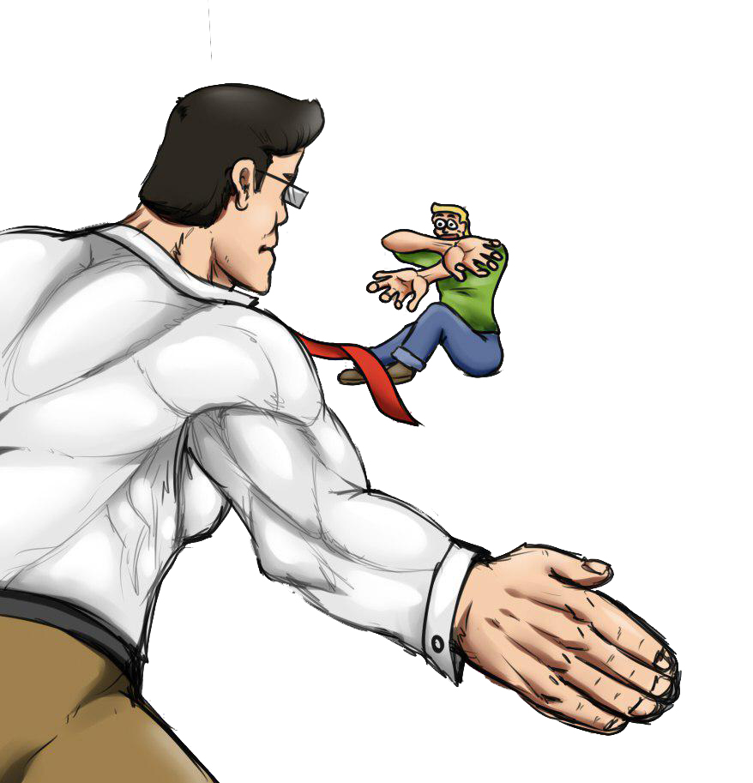

Cover By Jose Eladio Macias Calcinez

Contents

Section I – Game Overview 4

Game Concept 4

Feature Set 4

Genre 4

Game Flow Summary 4

Look and Feel 4

Project Scope 4

Levels 4

Number of NPCs 4

Section II – Gameplay and Mechanics 5

Mechanics 5

Power Ups 5

Economy and Upgrades 5

Game Options 6

Section III - Story and Narrative 6

Plot Elements 7

Game Progression 7

License Considerations 7

Cut Scenes 7

Section IV -Game World – The City 10

Area #1: The Neighborhood & City Street & Parking Lot 10

Physical Characteristics 10

Levels that use area 11

Connections to other areas 11

Area #2: The Workplace 11

Physical Characteristics 11

Levels that use area 11

Characters 11

Bob 11

Back story 11

Personality 11

Look 12

Special Abilities 12

Relevance to game story 13

Section V - Interface 13

Visual System 13

HUD - What Controls 13

Menus 13

Control system 14

Section VI – Game art 15

Style Guides 15

Characters: 15

Environments 16

Cut scenes 17

Section VII - Levels 17

"Work Stage 1" 18

Level 1.1: back to work (Alternative title: Taking it to The streets) 18

Level 1.2: Parking Ticket 18

Level 1.3: Office Party 18

"University Stage 2" 18

Level 2.1: Extra Credit 18

Level 2.2: Unacedemia 18

Level 2.3: Aluta Finito 19

"Bank Stage 3" 19

Level 3.1: Rat Race 19

Level 3.2: Old Rope 19

Level 3.3: Swine 19

"Police Stage 4" 19

Level 4.1: Domestic Assault 19

Level 4.2: Steve Irwin was here 19

Level 4.3: Citizen's Unrest 19

"Army Stage 5" 19

Level 5.1: Think Tanks 19

Level 5.2: National Insecurity 19

Level 5.3: Commander in Sheep (Title pending) 19

"Final stage" 20

Level 6.1: I'm Taking the Dog 20

Level 6.2: Pre-nup snub 20

Level 6.3: Unholy Unmatrimony (or Having a Domestic, Steel thy hand) 20

Section VIII - AI 20

Standard NPCS 20

Roving: 20

Special NPCS 20

Bosses: 20

Music and sound effects 20

Sound effects 20

Music 21

# Section I – Game Overview

## Game Concept

The game is a side scrolling beat-‘em-up platformer, based around the primary mechanic of a constantly depleting health bar that is replenished on successful hits. The player will go through each level of the game attempting to beat it before the timer hits zero.

## Feature Set

* Basic platforming (running, jumping, etc)
* Basic combat
* Self-depleting health bar
* Refilling health bar on successful hits
* Power-ups granting temporary abilities
* Shop providing purchasable upgrades when a player loses

## Genre

Action platformer/ side-scrolling beat ‘em up.

## Game Flow Summary

The player moves through the game by moving right enough to cause the screen to start scrolling or left enough to do the same. The game should ideally be fast paced, where movement and progression through the level is quick.

## Look and Feel

The visual style of the game is noir with coloured highlights, with a similar feel coming from the rest of the sound track to contrast nicely with the silly violence.

## Project Scope

### Levels

There will be three levels of varying length in addition to a tutorial level and final boss. The first will be the protagonists home, the second the streets, the third, /tbd/, the fourth the office and finally the bosses office.

### 

### Number of NPCs

All NPCs in the game will be enemies. There will be three types of NPCs in the game; civilians who take one hit to put down and cannot fight back, two are fighters/police who take two hits and can hit back causing a slight time reduction if given the opportunity, and third the boss who starts the fight wind up an attack that will cause a huge time reduction if it hits, to win the player must hit his knees multiple times in a short span of time to cause him to fall so you can hit his face and finally defeat him.

# Section II – Gameplay and Mechanics

## Mechanics

### Power Ups

To pick up a power up the player just needs to walk over it and it will immediately start to take effect. These effects are temporary and will disappears after a period of time, the amount of time this takes depends on the power up itself. Picking up the same power-up again will cause it to gain an upgraded version of that power-up. Power-ups are placed is levels with intent to provide variety to the levels but also randomly in certain scenarios after dropping from defeated opponents. Picking up a power-up will overwrite the one currently in effect. The list of power ups is as such;

* Fish Dance – level 1, shoots fish out when attack that do half attack damage, level 2, shoots fish out that do damage that’s the same as attack damage
* Pimp Slap – level1, provides a score bonus when a combo ends depending on how high the combo was, level 2, decreases the time until a combo ends
* Summon the THUN-DA! – summons a lighting strike that hits the nearest enemy when picked up, not upgradable, effect is instantaneous
* Budhi-smacker – level 1 slows the decrease of health for the duration of the power up, level 2 completely freezes the decrease of health for the duration of the power-up

### Economy and Upgrades

When a player loses a level, the score they earnt can be spent in a shop to buy permanent upgrades in order to make the game easier for the player to get through. The upgrades are as follows;

* An increase to the starting amount of health
* An increase to amount of time a power-up lasts#
* An upgrade to base run speed
* An increase to how often you can slap

## Game Options

The adjustable options for the game are as follows;

* Fx volume
* Music volume
* Voice Volume

# Section III - Story and Narrative

The game is based on one man’s path of retribution as he goes around his city slapping everyone he can find. We start off in a typical office workplace that you could find anywhere. On the highest floor, in the Boss’ office we find our main character (Bob Protag) taking verbal abuse from his boss. We find out that the boss isn’t even mad at him for making a work-related error or anything like that, he just can’t stand Bob’s personality. How Bob doesn’t talk back, speak up from himself or show any signs of strength. Furious with his lack of response to all the abuse Bob is getting, his boss decides to fire him and tells him to pack up his belongings. Bob, without saying anything at all, just does as he is told and packs up his belongings and decides to go home.

When he arrives home he finds out that his girlfriend of 2 years is sitting in the living room with a fully packed suitcase. Before he can even say anything, Bob’s girlfriend begins talking about how she’s moved on, how he can’t do anything for her anymore and that he needs to leave the house that, ironically, he pays mortgage for. While she’s talking, Bob can smell cigarettes which is odd considering neither of them smokes but then, he figures out what’s happening. Everything goes silent in Bob’s head. He can’t hear anything or think about anything, it’s all blank to him and he decides to just, slap his girlfriend. The second he does so he feels an emotion he’s never felt before, relief. That relief instantly turns into anger as he wonders why didn’t think of doing that before. With this new-found sensation as well as a bit of rage, Bob decides to go out into the neighborhood and starts slapping anyone and everyone who comes across his path. Without even thinking about it he finds himself walking towards his old workplace.

Bob goes from his house to his old job, through the city and his office’s parking lot, slapping any and everyone who comes his way. Even during this short period he’s gotten better at slapping people and makes his way towards his boss. He could’ve taken the elevator but no, slapping everyone on his way to meet him was too good of a chance to pass up, and so he goes, up the stairs through every floor of the building he used to work in, slapping each and every former colleague without hesitation until he reaches the secretary. The secretary shows no sign of emotion as they explain that Bob can’t go through but one slap changes everything and he makes his way inside. Finally, Bob and his boss meet each other again. The boss’ confusion quickly turns to anger as he prepares to fight Bob but he has no idea that this isn’t the same man he fired a few hours ago and an epic fight begins.

Afterwards, the boss concedes defeat and as Bob makes his way down the office through the elevator, he realizes his hand hurts, a lot. He slapped so many people today in a fit of rage that now that the adrenaline is starting to wear off he can feel the throbbing in his hand. Bob decides to walk towards his local pharmacy when he suddenly hears chanting in the distance. He remembers that there’s a university near his place of work and decides to walk towards it to see what’s going on. Upon arrival, Bob sees a large group of student protesters complaining about some pathetic non-issue. A few seconds of their pointless chanting was enough to enrage Bob and just like that, he’s ready to slap some people once again.

## Plot Elements

The story of One Hand Clap explores the consequences of when one is pushed to the edge of insanity. This game follows a very simple idea : don’t anger someone or they will slap you, repeatedly, if necessary.

## Game Progression

The game follows a classic platform style progression. You control one character as they make their way from one side of the level to the next doing various things to get points and complete objectives (a.k.a. slapping people). The first level (Neighborhood) can be seen as a sort of tutorial as you get to grips with your slapping abilities, what you can and can’t slap and gradually as you make your way through the city and eventually, your old workplace, the game gets harder and harder. You start to find people who don’t get knocked out with just one slap and you find new and inventive ways to slap people. By the time you reach the Boss level you’ll be efficient in playing the game (and hopefully had lots of fun on the way here).

## License Considerations

Most of One Hand Clap’s design and ideas are original (we checked) so there was little to worry about in that regard. However, the biggest problem with creating the game was sound. We had to do a lot of research in terms finding music and sound effects that were royalty free music. We also created a bit of our own sound effects and music as well as we had a very specific vision in mind when it came to creating this game.

### Cut Scenes

#### Cut scene #1

##### Actors

The characters involved are Bob Protag and his Boss.

##### Description

This scene is where we first meet our main character and his boss who would eventually become the first boss in this game.

##### Script

Boss: What do you have to say for yourself?

Bob: . . .

Boss: See? This is the problem with you. You can’t stand up for yourself. You don’t fight back.

Bob: . . .

Boss: We need Warriors in our organization. People who are prepared to go the extra mile to get the results we need and you, well you’re just a disappointment.

Bob: . . .

Boss: That’s it. Get out of my office. You disgust me.

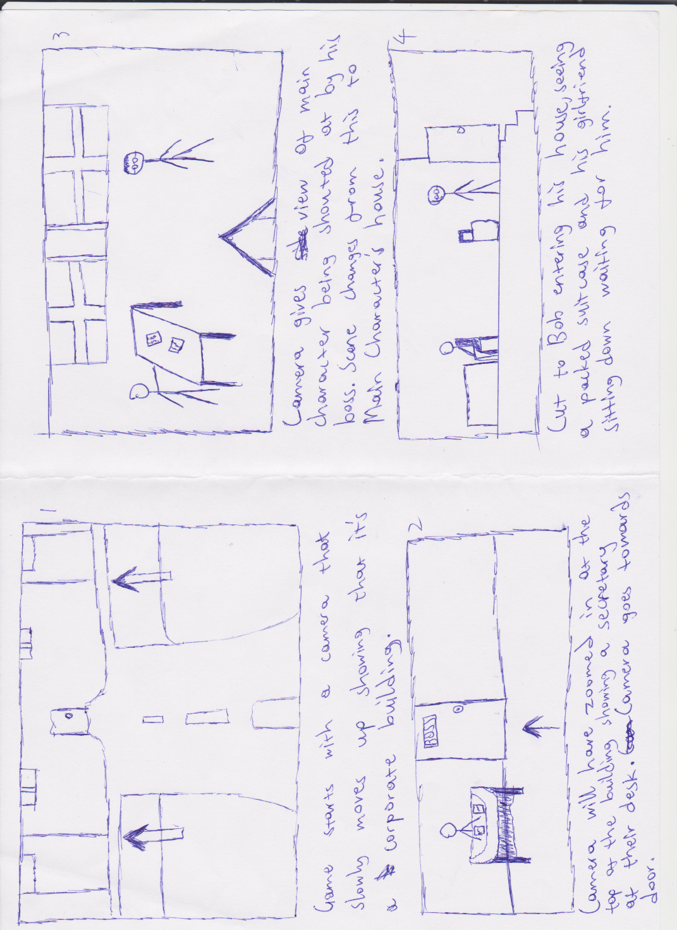

#### Cut scene #2

##### Actors

The characters involved here are Bob and his girlfriend.

##### Description

This scene is where we meet Bob’s girlfriend who’s dumping him. It’s also where the game begins and you can start controlling the main character.

##### Script

Girlfriend: We need to talk.

Bob: (Confused)

Girlfriend: This just isn’t working out. We’ve been growing apart for the last few months and to be honest, I just don’t love you anymore.

Bob: . . .

Girlfriend: God you’re such a wimp. I can’t even remember why even agreed to go out with you anyways, this was a mistake. Meeting you was just such a huge mistake.

Bob: . . .

Girlfriend: I’ve packed your stuff already, so you can just go.

Bob: . . .

Girlfriend: What are you waiting for? GO!

(Slap)

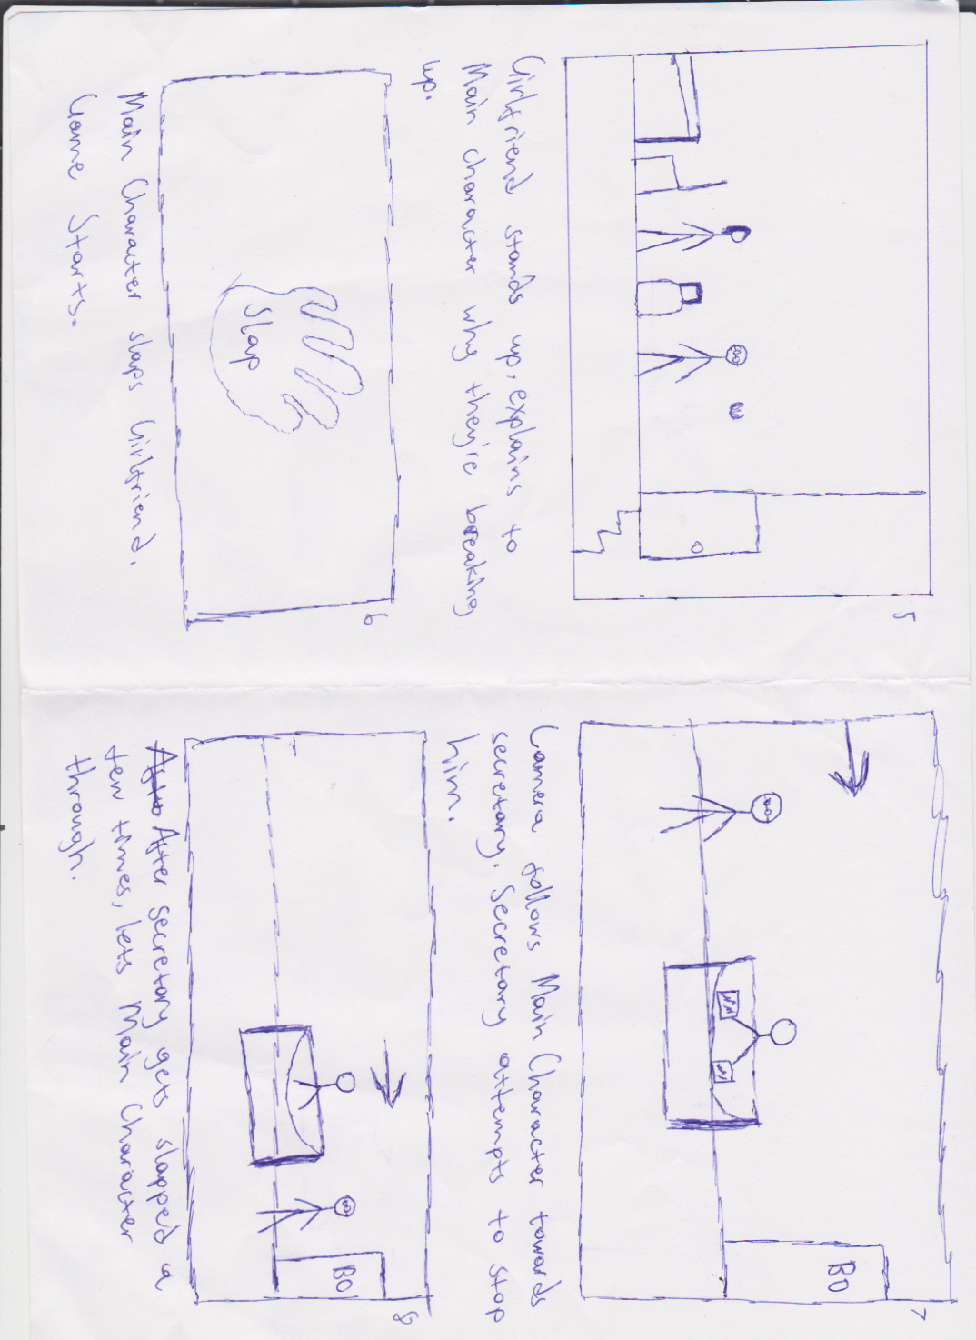

#### Cut scene #3

##### Actors

Bob and a large group of university students are involved here.

##### Description

After a lot of climbing and slapping, Bob finally manages to get to his Boss’ room and confront him once and for all.

##### Script

Boss: Who are you? How did you get in here?

Bob: . . .

Boss: Oh wait….I remember you.

Bob: . . .

Boss: I don’t know what you’re doing here but if you’re responsible for all the complaints down stairs.

(Bob slaps Boss)

Boss: WHAT! YOU WILL PAY FOR THAT!!

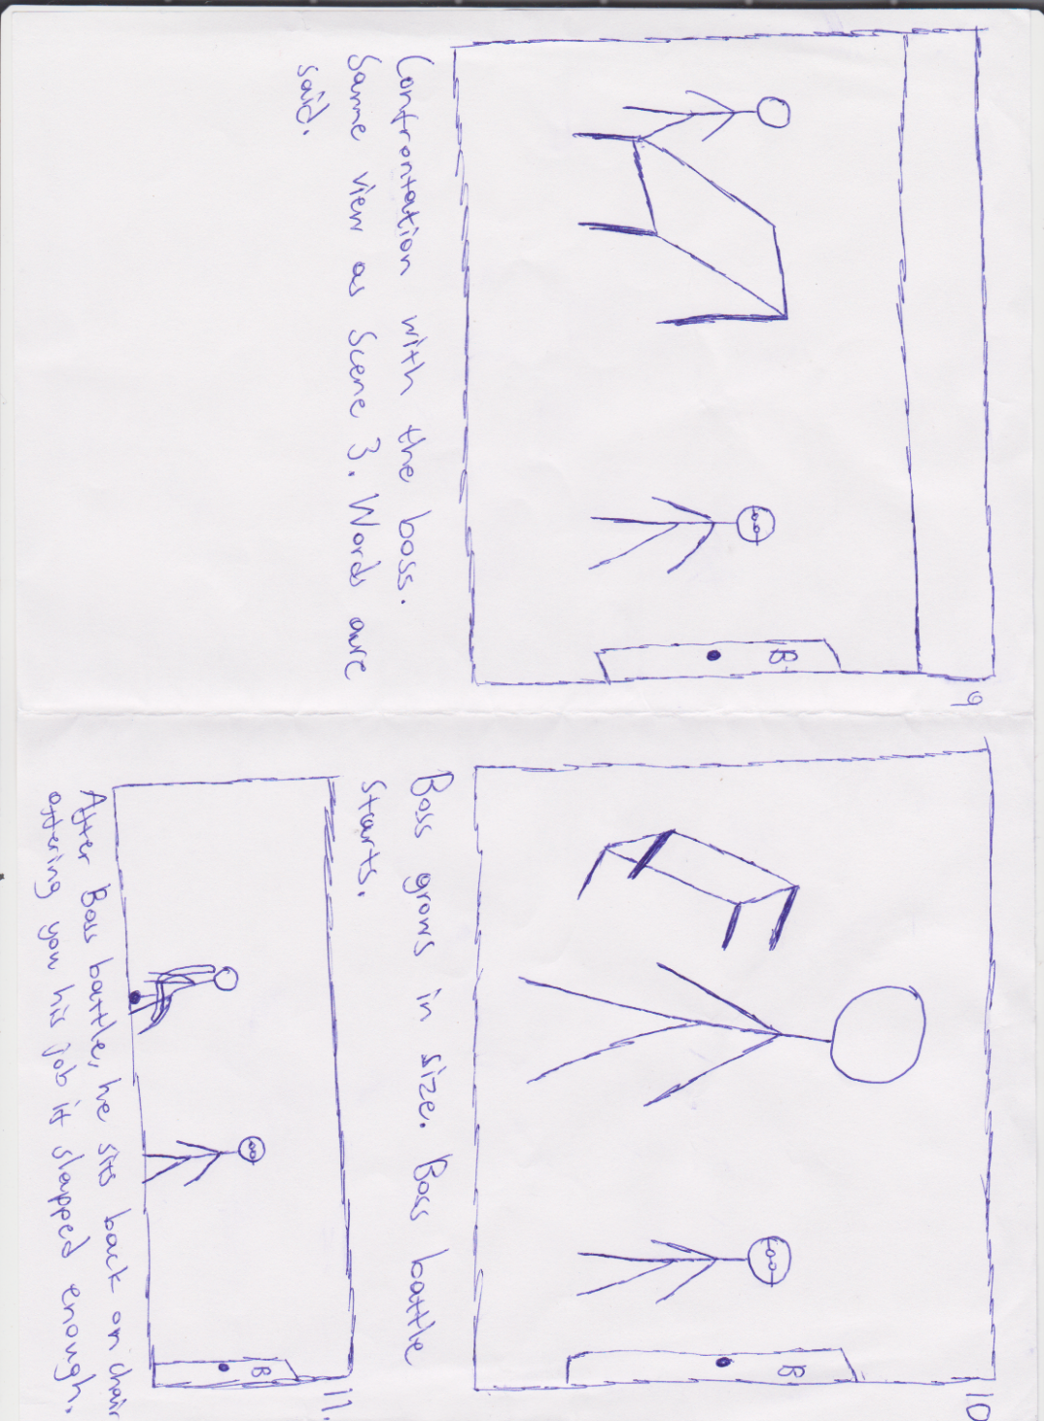

# Section IV -Game World – The City

General look and feel of world

The City is a normal one. A lot of the buildings are very modern and a few sky scrapers here and there. The areas of interest involved in this world are the neighborhood, the city street leading to work, the parking lot, your former work place and finally, the university.

## Area #1: The Neighborhood & City Street & Parking Lot

General Description

This area has one notable building, your house. This is where you start the game. Bob’s girlfriend is laying on the floor and although Bob himself can’t see him, we can see there is a man upstairs on top of the bed confirming what both you (the player) and Bob thought his girlfriend was dumping him for.

### Physical Characteristics

At the beginning, there are a few buildings and a few people walking by (easing you into the game) however as you progress further forward into the city, you start seeing more people, more buildings, less nature. You will also notice on your way to the parking lot, a local pharmacy and a road that leads to a university into the distance (which you can’t go to yet) and at the end you will be at the car park where, there are a few former colleagues, a security guard who checks for I.D. and a revolving door that leads into the reception.

### Levels that use area

Levels 1 and 2 will take place in this area, Level 1 will deal with the basics of the game whereas level 2 will be more challenging.

### Connections to other areas

This area leads to the workplace where the final level is as well as the university were the game concludes (for now).

## Area #2: The Workplace

General Description

This is the final area you will be able to play in. The hardest enemies will be in this area as well as the final Boss you have to fight in order to finish the game. All your knowledge and skills you gained from the previous levels will be tested here to its fullest.

### Physical Characteristics

You start off at the reception. You will notice that there is an elevator that could take you to the highest floor however you can’t access (or rather, you don’t want to). Instead you make your way to the staircase and go through each floor slapping people. The workplace is generally a gloomy place. There is a lot of gray, office computers and work desks, printers and other office supplies laying around each floor. There will be small room where the secretary is who tells Bob he can’t go through before getting slapped. The Boss’ room has a desk with office supplies which get tossed aside for the boss fight.

### Levels that use area

Levels 3 and 4 will take place here (Level 3 being the floors leading up to the boss battle and Level 4 being the boss fight itself.

Connections to other areas

This area is connected to the Parking Lot which you will go through one last time before finishing the game.

# Characters

## Bob

### Back story

Bob is your typical salary man. He grew up in a nuclear family household, no brothers, no pets, just him and his parents. He went to primary and secondary with no major incident happening in his life. He also managed to go to university with no complications and also got a job near said university. Shortly after graduating he met his girlfriend and through either extreme luck or pity (no one really knows), he manages to get her to go out with him. He also manages to get a down payment on a house in the suburbs and is steadily paying his mortgage. His girlfriend does not pay any of the bills.

### Personality

Bob is a typical introvert beta-male. He was told he had a whiny voice by his parents when he was younger and generally stays quiet because of it. He’s incredibly shy and has managed to avoid getting into any incidents throughout his life. His general approach of doing what he’s told and avoiding people has led to him becoming a nobody.

### Look

#### Physical characteristics

Bob wears a white shirt with a black tie, black trousers as well as black shoes. He has short hair and glasses. He has no unique features and is generally un-noticeable unless you’re looking for him. He’s also very skinny.

#### Animations

Bob starts as a normal looking man however over time during the game he becomes stronger physically. Gradually, this body change affects the way he walks as well as how he slaps people (although slapping is mostly affected by power ups)

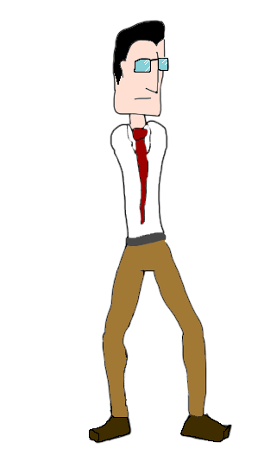

## Special Abilities

*Fish dance - A fish weapon to increase damage

-> Large Fishy dance (level 2 attack)

-> Flying Circus Fish dance (level 3 attack) - shoots fish projectiles.

Pimp Hand -Power up that increases points currency in tandem with the combo system

Dust Devil (base attack) - sends enemy reeling, the knockback is strong enough to send enemies colliding into other enemies.

->Tornado (level 2 attack)

->hurricane (level 3 attack)

The Wife Beater – This will half the amount of damage you do normally however when timed right it can do up to 3x normal damage.

Summon the THUN-DA!!! – A slap so hard lightning comes down to hit its enemy and applies a Stun to nearby enemies.

Budhi-smacker - reduces the amount of health loss per-second.

Ensmitenment- + a speed boost to attacks.

Slap-gri-la - once activated there is no health loss persecond for the duration of the power up.

All-mighty-smiter - complete invincibility for the duration of the power-up.

The End of it All – A slap that ends everything by creating a black hole.

1000 hand slap – Slap 1000 times. Quickly.

## Relevance to game story

Bob is the main character, so the entire game and its story revolves around him and his actions.

Relationship to other characters

Bob makes no new relationships after slapping his one and only partner and leaving her on the floor, motionless

# Section V – Interface

## Visual System

### HUD - What Controls

In the HUD we will find two main important features, the timer and the power bar, the timer is easy enough to understand, at the start of each level you are given a certain amount of time to complete the objective, to increase the time the player will slap people. if it goes below a threshold the music will slow down and the screen will go dimmer until it eventually goes dark, making it difficult to see how much time the player has or how much power has he obtained.

The power up bar will be located just below the timer at the top left corner, where also will be located a portrait of the main character in the attire of the level (or if the power icon or not.).

*In-game HUD.*

### Menus

There will be a total of— menus. The first one will be the main menu where the player must click “esc” or the top right button in the in-game HUD to access. This menu will pause the game and appear in the middle of the screen as a list with the following options;

1. Options - here the player will be able to edit option such as; master volume, music volume, speech volume etc... (Discuss in group)
2. Restart level - This option is self-explanatory, if the player decides to reset the level he will just have to access here, and it should restart it.
3. Restart game - Also self-explanatory, if the player wants to restart the whole game this is where he would have to click. This button however prompts a menu asking if the player is sure about the decision he is about to take.
4. Exit to windows - This will shut down the game, as the last one, it will prompt another menu asking the player for confirmation before doing such action as it may be unintended.

*Main menu*

### Control system

Keys in use

Up arrow - Jumping upwards

Left Arrow- Movement to the left

Down- Movement downward the on a platform or if not, ducking.

Right arrow- Movement to the right

Spacebar - slapping (movement oriented, if player i looking right he will slap right, left will slap left and ducking will make a low slap.) repeated spacebar pressing should initiate a combo if hitting an enemy.

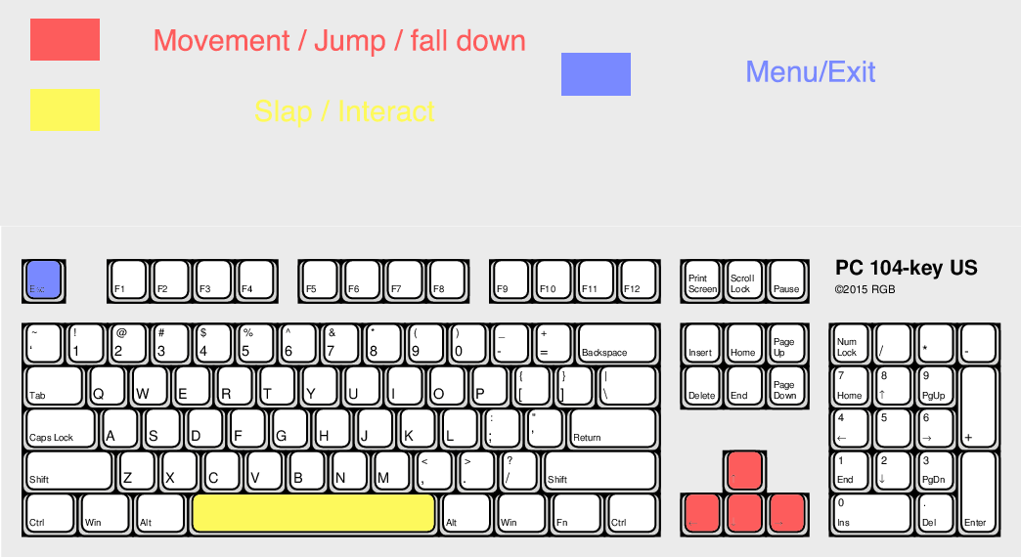ESC - opening main menu.

*Keyboard controls*

If using a controller (PlayStation example)

X for jumping/ unless on menu where it will count as a click.

Square for slapping

Triangle as the action button

O to activate power up/ except on menu that it will count as a back key.

Arrow keys for movement and jumping.

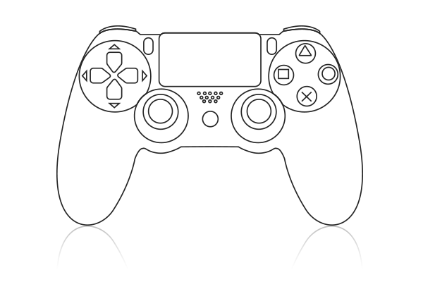Option/start for menu

Menu

Movement

Jump

Activate/ Back

Action

Slap

*PlayStation controller*

# Section VI – Game art

## Style Guides

The game art style is based on 60’s and 70’s music and cinematography style including films such as “Im gonna git you sucka”, “Blacksploitation”, “Austin Powers” and also a mix of Film noir style.

These 4 distinct types of movies follow a very distinctive style of their own and make the concept of the game even more intriguing.

60’s and 70’s had a very distinguishable art style that clearly influenced the preproduction of this game.

## Characters:

Bob Protag: Generic protagonist with very little nerve. Plain looking and a complete wimp. At least until he loses everything….

B. Wife: Wife of bob, cheated him and now dumps him. The first victim of bob’s radical change.

B. Boss: Bob’s Boss, also a boss in the game. He fires Bob and becomes his main objective.

Pedestrians: Normal people, normally scared of Bob’s actions.

Police: Main line of defense pedestrians have, they will do anything in their hand to stop Bob… Not that they will succeed in it… Will they? Their design was based on the notion that a police man should be a challenge to the player, big, bulky and imposing, taking more than 1 hit to take down

University protestors: General SJW’s, try to convince Bob that he is a monster for being male. They may regret that.

Military: They appear when Bob is getting out of control. Not much to do against them unless you get them by surprise.

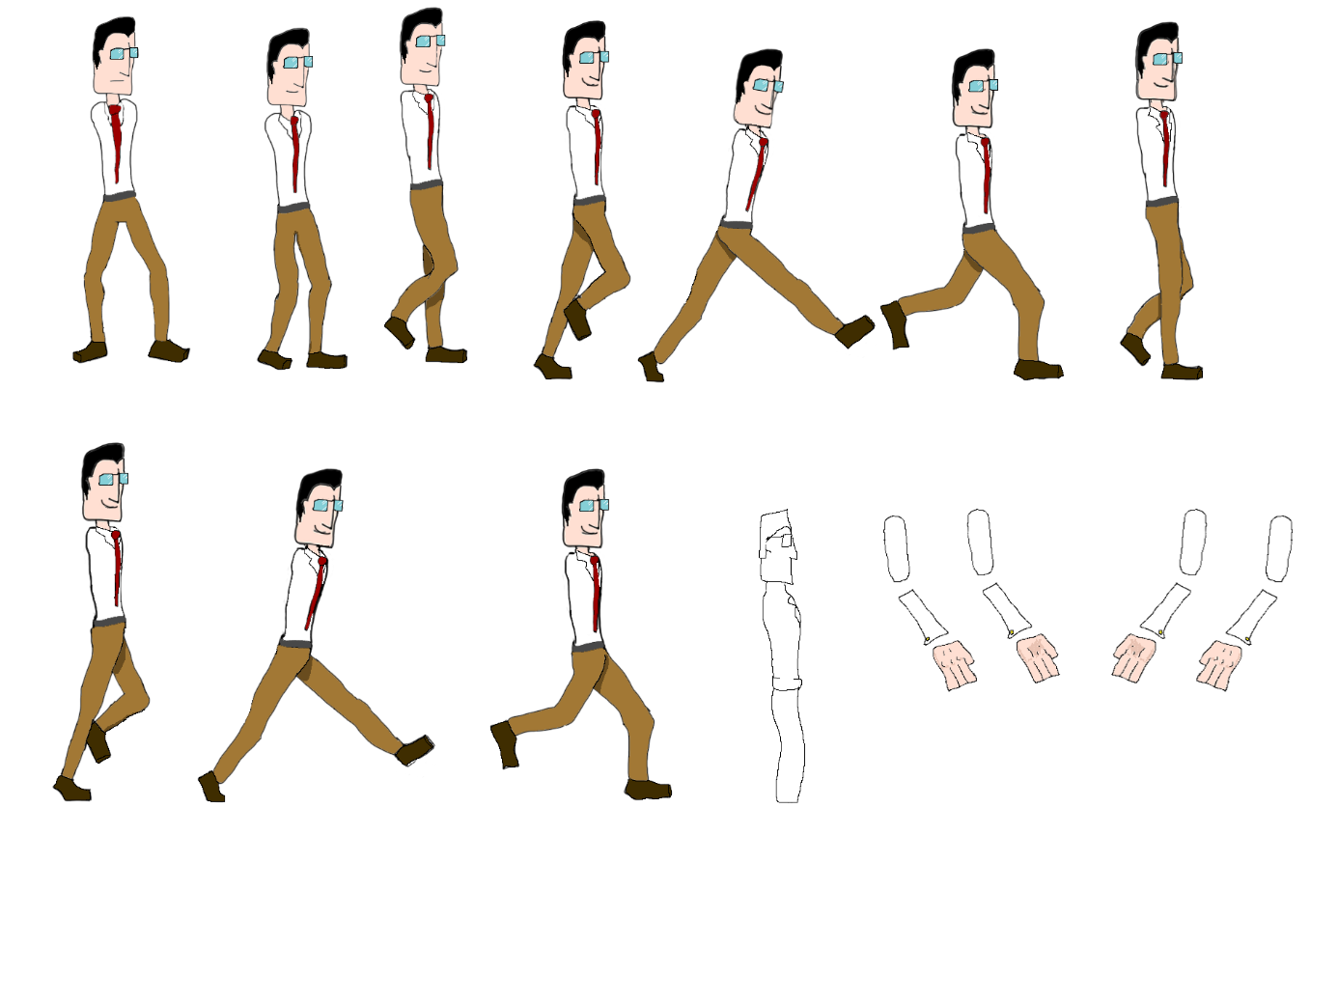

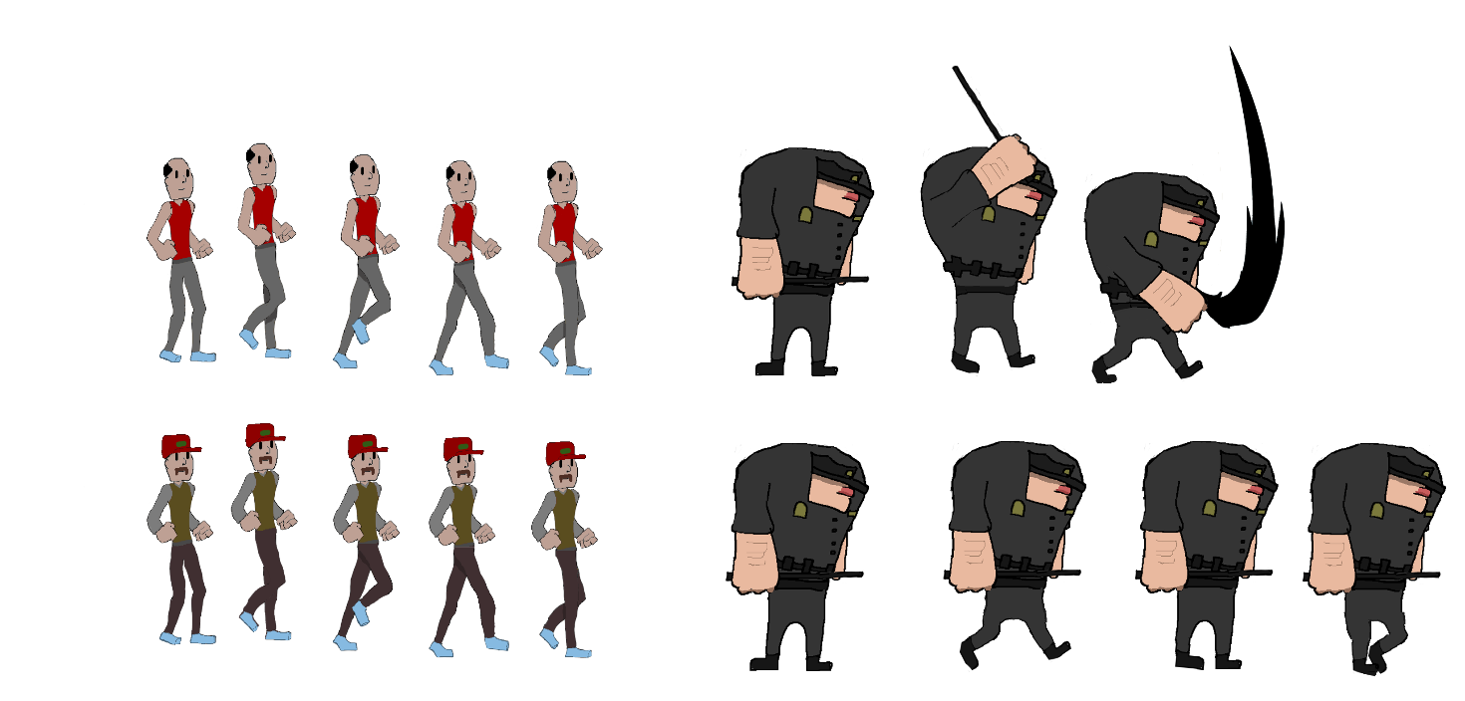

*Example of characters*

# Environments

The environments are based on North American areas, ranging from interiors to exteriors.

The first stage would be divided into 3 different levels: a north American neighborhood, with tall buildings, supermarkets and other objects scattered through it, a parking lot, with some cars, some elevators where npc’s can come into play and a few upper levels, lastly the main office building where our main character works, where you can find cubicles desks and other various objects where npc’s can appear to keep the level filled.

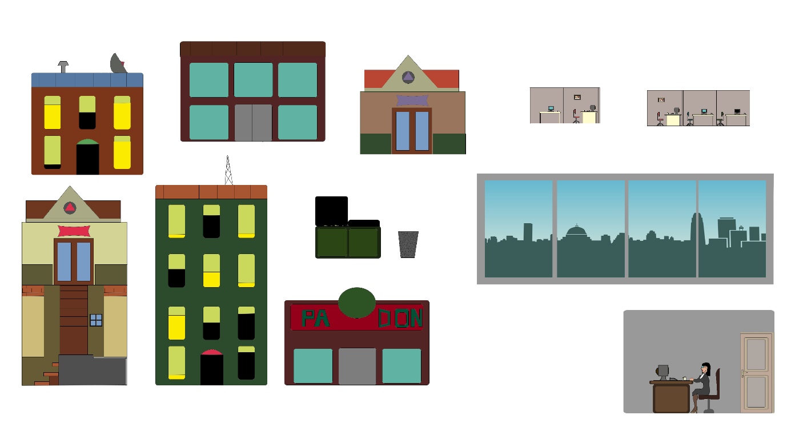

*Example of backgrounds and objects for environments*

These environments will have some interactivity with the player, cars can be jumped upon, and some roofs may be accessible with the help of some other objects such as trashcans boxes etc.… Some of the npc’s will be able to make use of them too either to hide or to get to the player to attack him.

## Cut scenes

The player will be prompt into a cut scene when he finishes each level, rewarding him and making the main character advance into the next level.  
  
These cut scenes will consist of the player in an animation of triumph for a few seconds followed by them going outside the view of the camera through the right. After this, it will fade to black and load the next level, where he will appear from the left side of the screen, at the start of the level.

In some levels however, the cutscene may be longer and include some amount of interactivity, such as keep hitting a boss or just walking away out of the level.

# Section VII - Levels

Levels are two-dimensional side-scrolling areas with natural looking platforms, i.e. If a person could jump on it in a single bound in real life, they can bounce on it in game. The level progression can be grouped into "Stages" based on the narrative construct.

Every level is based on a sense of skewed reality. This can be better explained as: every in game object has a sense of realism to it(outside of the main overriding aesthetic of the art style) but is a little off to show case the slight deviation from norm that the protagonist is going through.

Each level is a progressive and shares a sense of diagesis with the narative to ensure player immersion to both storyline and game play. this could better be explained by going through each level individually

## "Work Stage 1"

Synopsis: Bob Protag realises, the power he posesses and decides to take it to the streets... and show his old boss.

### Level 1.1: back to work (Alternative title: Taking it to The streets)

Objective: Move right, attacking all enemies and NPCs till you reach the work carpark.

Physical Description: Lateral construction, few platforms up and down stairs,

### Level 1.2: Parking Ticket

Objrctive: Go up the car park, attacking all Enemies and NPCs till you reach the top.

Physical description: Vertical construction, lots of platorms (roofs of buildings), The car park at the bottom with lots of NPCs and fewer as the player rises, with many more violent enemies as the level progresses.

### Level 1.3: Office Party

Objective: Go through the level, collecting poer-ups and health, defeating all obstacles then defeat the boss

physical description: Lateral construstion with b oss room at the end. Lots of violent enemies with a secretary before the boss to revive the player pre-boss fight.

## "University Stage 2"

Synopsis: After satiating his vendetta, Bob Protag decides to deal with the unruly students and their power hungry lecturer.

### Level 2.1: Extra Credit

Objective: rush through the enemies to reach end of the level. Find the lecturer

Physical description: A lateral platformer with tables and chairs, woter fountains and bike sheds... numerous NPCs obstucting view of the objective.

### Level 2.2: Unacedemia

Objective: rush through the enemies to reach end of the level. Find the lecturer.

Physical description: Top -down beat em up; quick short lines of levels with numerous combative enemies leading to a stairwell then the next short line.

### Level 2.3: Aluta Finito

Objective: rush through the enemies to reach end of the level. defeat the lecturer.

Physical description:: Roof tops Lots of gaps to fall through, quickly rush through combative enemies then the Lecturere boss fight.

The levels following will follow a similar physical structure.

## "Bank Stage 3"

Synopsis: Now, time for Bob to head to the bank to deal with the corrupt banker who stole his pesion plan

### Level 3.1: Rat Race

### Level 3.2: Old Rope

### Level 3.3: Swine

## "Police Stage 4"

Synopsis: On the way home Bob is acosted by the police who accuse him (falsely) of being and armed robber.

### Level 4.1: Domestic Assault

### Level 4.2: Steve Irwin was here

### Level 4.3: Citizen's Unrest

## "Army Stage 5"

Synopsis: After the 'misunderstanding' with the police on his way home, Bob Protag's house has his house bombed in and decides to show the army how it feels to be homeless.

### Level 5.1: Think Tanks

### Level 5.2: National Insecurity

### Level 5.3: Commander in Sheep (Title pending)

## "Final stage"

Synopsis: Seeing his ability has empowered him at the cost of his old lifwe. Bob retrurns to his ruined home. Attacked by super-heroes, He ends up having to face his super-powered ex-girlfriend.

### Level 6.1: I'm Taking the Dog

### Level 6.2: Pre-nup snub

### Level 6.3: Unholy Unmatrimony (or Having a Domestic, Steel thy hand)

# Section VIII - AI

## Standard NPCS

They are of three variants.

Still:

Spawned at the start of the game... non moving, non respawning.

## Roving:

Spawned from spawn points. respawning a while after death. They do not attack the player and occasionally drop

items.

vigilante:

(optional) Like roving they spawn from a spawn point. They may chase the player for a few steps then give up the hunt (while in their circle of influence) occasionally dropping an item pickup.

## Special NPCS

Security/ police/ military:

They have a stable short range roving state. When the player enters their field of influence, they will consistantly chase the player till the NPC is out of view.

## Bosses:

Each boss will have thier own specialist attack routines based on story and attack routine.

Music and sound effects:

## Sound effects

Strike: A small clap sound effect with heavy reverb to simulate a strike

thunderclap: for use with the item "Summon the Thunda"

cash register: a mid tone cash register sound effect for use with the "pimp hand" item

spalsh: A splash sound effect for the item "Fish dance"

Voiced lines while attacking othe odd enemy.

Item pickup: A pinging soundeffect similar to a dinnerbell

## Music

Each level will have variations on the same themeall in a 70s funk and disco style.

Introductions to levels use the same musical piece, a soft jazz piece.